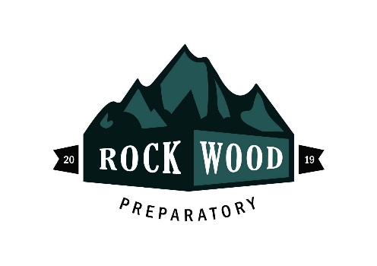
STUDENT MEDIA CONSENT AND RELEASE FORM

Throughout the school year, students may be highlighted in efforts to promote Rockwood activities and achievements. For example, students may be featured in materials to train teachers and/or increase public awareness of the Rockwood and our programs through newspapers, radio, television, the internet, DVDs, displays, brochures, and other types of media.
The undersigned hereby authorizes and grants to Rockwood, its employees, representatives and authorized media organizations and assigns an irrevocable license and permission to use my child’s name, photograph, likeness, voice, testimonial and biographical material, in whole or in part, for publication or reproduction in any medium including but not limited to television, radio, print media and the Internet, among others, for any purpose including but not limited to public relations, education, advertising, marketing, training and research. My consent extends to such use without restriction or limitation as to time or geographic boundary.
I hereby waive all rights I may have to any claims or demands for payment or royalties in connection with the use of any such materials, regardless of the purpose of such use or publication, and regardless of whether a fee is charged or collected by Rockwood for any product and/or service in connection with such use and publication. I also waive any right to inspect, review or approve any photograph, recording or other written material at any time, and waive the right to approve the use and medium of publication determined by Rockwood.
I understand that Rockwood owns all rights in and to any such photograph, recording or testimonial, including any copyright and/or trademark relating to such use, which Rockwood may be entitled to claim.
I further release and relieve Rockwood, its Board of Directors, employees, and other representatives from any liabilities, known or unknown arising out of the use of this material.
I declare that I am the legal guardian of the student named below, am at least eighteen (18) years of age and am legally competent to execute this assignment and release.
I certify that I have read and fully understand the terms and conditions of this Student Media Consent and Release Form and have the right and authority to execute this document.
The undersigned is the Parent and/or Legal Guardian of the named Minor and executes this permission and consent and release agreement and joins therein, on behalf of such Minor.
Student Name: _____________________________________________ Date: __________________________
Signature of Legal Guardian: _________________________________________________________________
Printed Name: ____________________________________________________________________________
Address: _________________________________________________________________________________
Phone: (H) _____________________________ Phone: (C) ________________________________________

